Assignment -- 5.4

Task Description #1:  
• Prompt GitHub Copilot to generate a Python script that collects user data (e.g., name, age,  
email). Then, ask Copilot to add comments on how to anonymize or protect this data.  
Expected Output #1:  
• A script with inline Copilot-suggested code and comments explaining how to safeguard or  
anonymize user information (e.g., hashing emails, not storing data unencrypted)

PROMPT :

Generate a Python script that collects user data (e.g., name, age, email, phone number, address) by storing the data in '.txt' file.

Code :

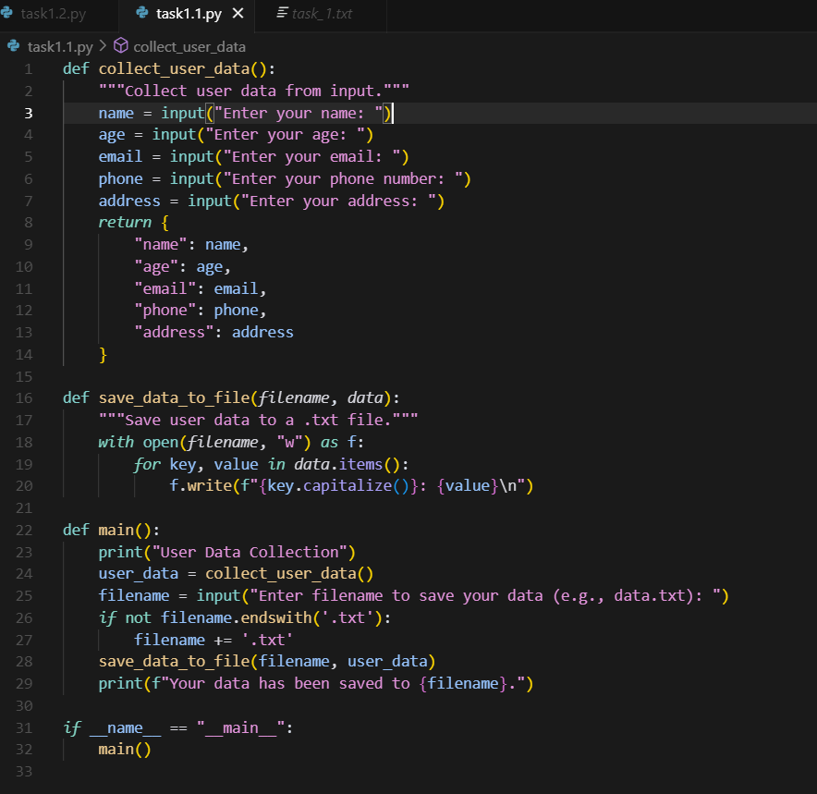

Output :

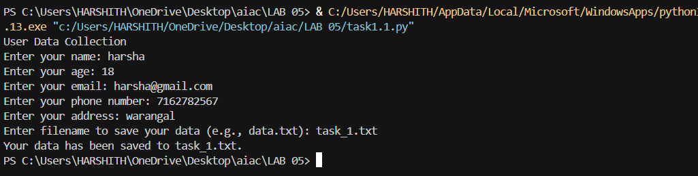

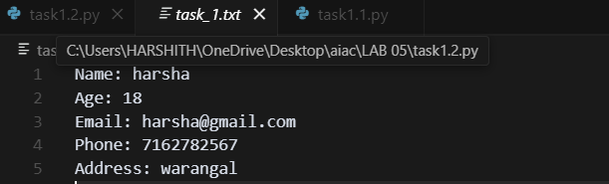

# 1.2

PROMPT :

Generate a Python script that collects user data (e.g., name, age, email, phone number, address) by storing the data in '.txt' file and add comments and make data the stored anonymize or protect this data like add password to file by create the password during the collection.

Code :

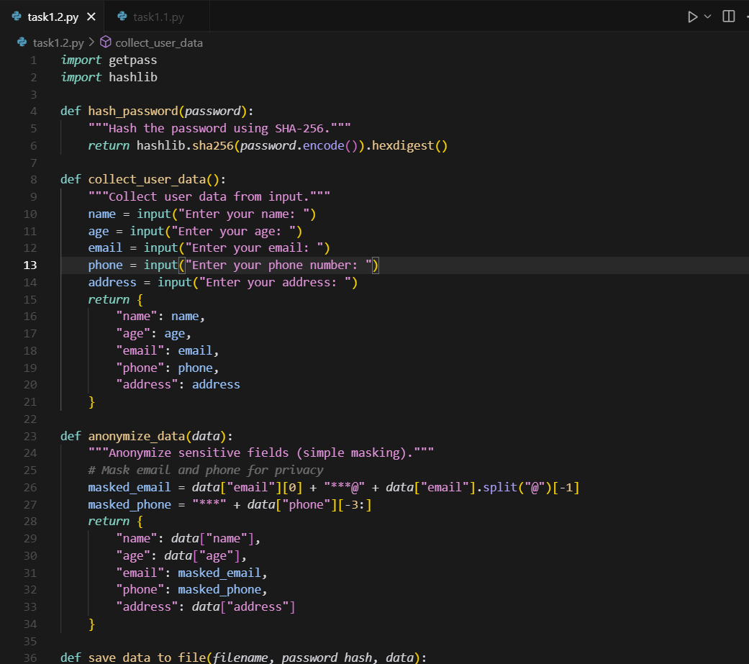

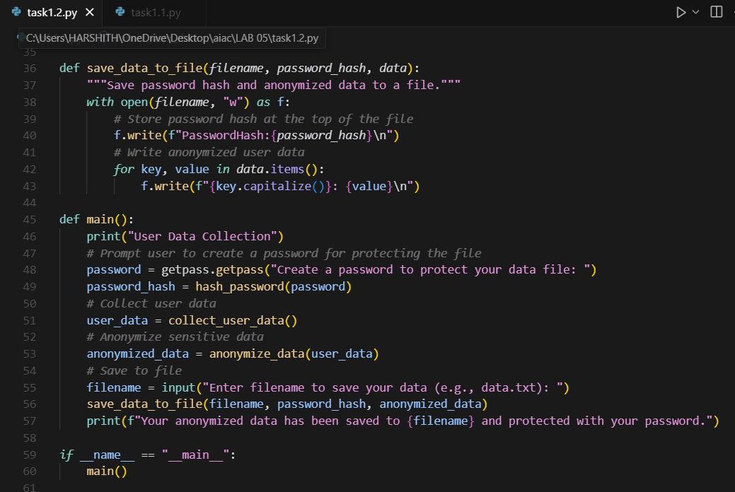

Output :

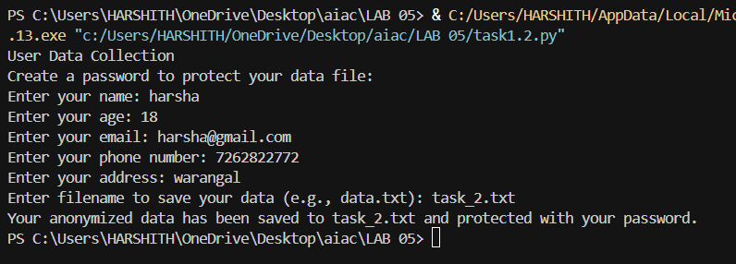

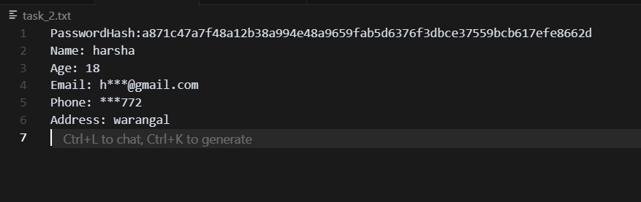

**Task Description #2:**

**•** Ask Copilot to generate a Python function for sentiment analysis. Then prompt Copilot to identify and handle potential biases in the data.

**Expected Output #2:**

**•** Copilot-generated code with additions or comments addressing bias mitigation strategies (e.g., balancing dataset, removing offensive terms).

PROMPT :

Generate a Python function for sentiment analysis and identify whether the sentiment is positive, negative, or neutral by taking the input from the console. Example: 1) How was the movie? He said it was an awesome positive sentiment. 2) How was the movie? She said it was an excellent negative sentiment.

Code :

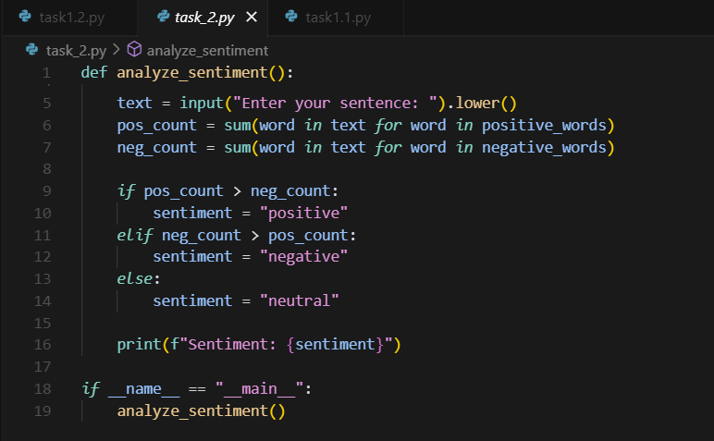

Output :

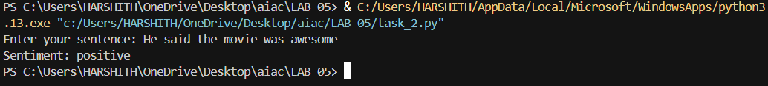

**Task Description #3:**

**•** Use Copilot to write a Python program that recommends products based on user history. Ask it to follow ethical guidelines like transparency and fairness.

**Expected Output #3:**

**•** Copilot suggestions that include explanations, fairness checks (e.g., avoiding favoritism), and user feedback options in the code.

PROMPT :

Write a Python program that takes user input from the console (e.g, searches like soap, mobile, toys, games) and recommends related products based on search history.

Code :

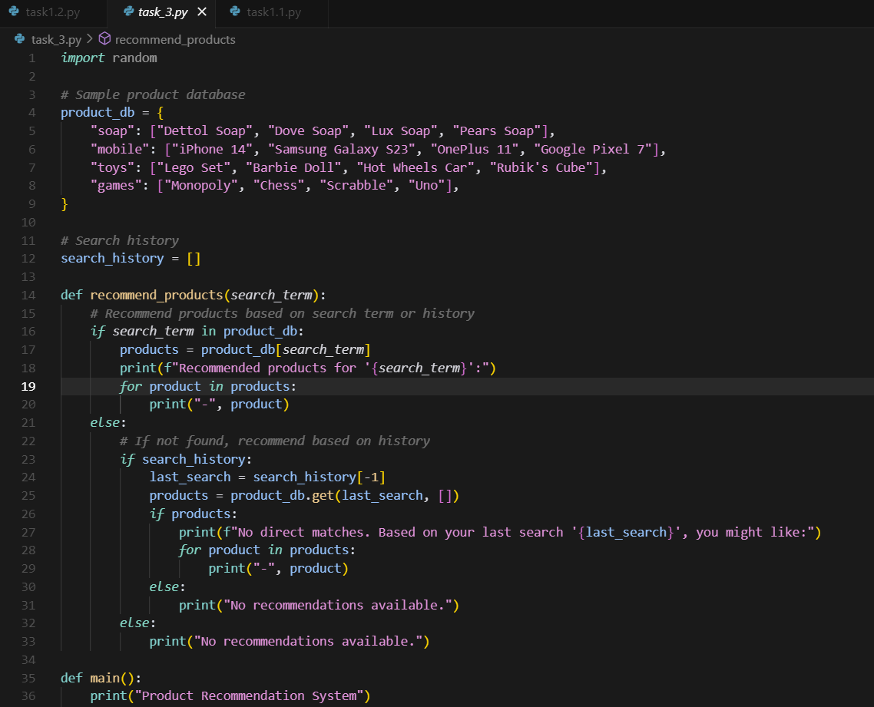

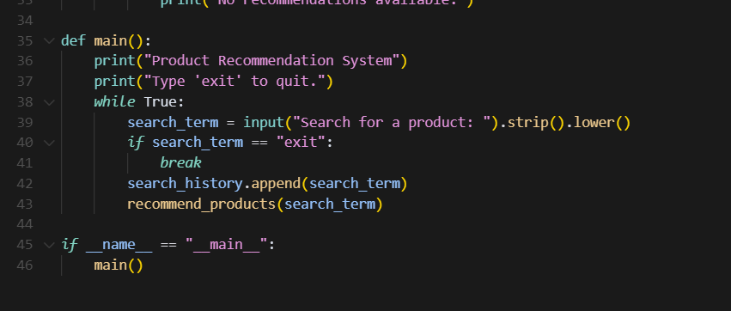

Output :

